Volunteer Management for the Non-Government Organization (NGO)

Background
About the organization and the system
The consulted organization is poverty elimination NGO. It has grown tremendously over the years and is attracting more and more volunteers both domestically and internationally. As it grows, there is an increasing need to coordinate and manage its volunteers, especially international volunteers as they require more administrative and logistic efforts. The current ways of manually handling documents and volunteers requires a lot of works and limiting the organization efficiency.
From the situational analysis and problems identified, our team proposed an integrated system with the aim of addressing the problems of volunteer communication, documentation, recruitment and retention.

Objectives of Systems
This document specifies the system to be developed. The objectives of the system are:
- To eliminate current cumbersome manual registration process, reduce meeting time, minimize errors and reduce the workload for coordinators.
- To better coordinate the volunteering process using an automated system that can capture and disseminate information in a more efficient manner.
- To provide a platform for volunteers to discuss, post their feedbacks and share their experience. This platform also serves as a recognition channel for volunteers since their stories are read and commented by other fellow volunteers.
- To evaluate/manage project progress and to keep in touch with volunteers.

Scope of Systems
The scope of system is defined as follows:
- Volunteer account management:
  - Allow user to register an volunteer account
  - Allow registered user to do profile management (update personal information, change password…etc.)
  - Allow registered user to indicate their preference and interest – such as what kind of activity they are interested in, what are their abilities and capabilities.
- Staff account management:
  - Allow administrator to register an staff account
  - Allow staff to do profile management (update personal information, change password…etc.)
- Project/Event Management:
  - Allow staff and volunteer to submit a voluntary project/event proposal
  - Allow project manager to do approval/ rejection for a proposal
  - Allow staff to invite volunteers to voluntary projects and events
  - Allow volunteers to choose to join projects and events
  - Allow project manager to create a project team and assign volunteers to various role depends on their preference and interests
- Itinerary Management:
  - Allow project manager and staffs to prepare trip itinerary and dissimilate to volunteers before the trip.
  - Allow project manager and staffs to update trip itinerary
- Feedback:
  - Allow volunteers to post feedback after their trips or projects, feedback will appear under project descriptions
  - Allow volunteers to share their experience by writing stories or articles and post the front page of the website.
  - Allow project managers to view feedback report for projects and events
  - Allow project managers to review stories or articles written by volunteers and approve them so that these stories will appear on front page.
  - Allow both anonymous and registered users to comment on stories and articles posted on front page.
- Reporting:
  - Allow project manager to track the status of a voluntary project or events – such as how many volunteers are in a project, what are the activities have been done, what are the feedbacks for the project.
  - Allow project manager to view volunteer-related reports such as how many hours on average a volunteer spend in a project, how many projects such she/he has joined.
  - Other reports
- Certificate management:
  - Allow system admin or project manager to define certificate template.
  - Allow project managers or staffs to generate certificate and send to volunteers for appreciation of their works.
  - Allow volunteers to view and download their certificates
- System control panel:
  - Allow system admins to use a front-end interface to define and manage configurable system parameter such as error messages, web themes, email template, system constants…etc.

- Forum:
  - The system shall integrate a separate forum for interaction between volunteers and staffs

User Characteristics
The end users of the system shall be the following:
- Volunteers.
- Coordinators – staffs
- Project administrators
- System admins

Operational Environment
The system shall operate in Internet and Intranet environment.
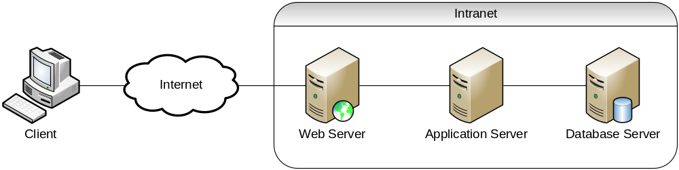

Non-Functional Requirements
The non-functional requirements of the system are described in the following subsections. They define how well the system is required to perform the functional requirements presented in section 3.

Performance Requirements
- The system shall maintain an average of 3 seconds to response to every request from Intranet user or Internet user.

Availability Requirements
- The system shall be available 24 hours a day, 7 days a week with 99% availability per year.

Reliability Requirements
- The combined hardware and software system shall have 99% reliability. In particular during a 24 hour running period the system should not be unavailable for a period longer than 2 hours in total.

Design Requirements
- The design of the system shall be flexible in order to allow extensibility and modifiability of the system.

Security Requirements
- The system should require all users to enter a valid password to logon to the system.
- Each user will be granted access only to functions that are compatible with their responsibilities.

